

MAD CEP

**TOPIC: Travel Mobile Application**

**ASSIGNED BY: Mam Mariam Memon**

#### PREPARED BY:

**Dua Mirani**

**(21sw084)**

**Doha kazi**

**(21sw115)**

**Faiza soomro**

**(21sw157)**

**REPORT:**

**Travel Mobile Application**

Comprehensive Travel App

This report explores the development of a mobile application designed to revolutionize the way people plan and experience their travels. By leveraging advanced technologies and intuitive user interfaces, this app aims to provide a seamless and personalized travel experience.

**Real World Problem Identification:**

1. Information Overload:

With the vast amount of travel information available online, it can be overwhelming for users to find the right destinations and plan their trips. The app aims to curate and present relevant information in a user-friendly way, reducing information overload.

1. Decision Fatigue:

Choosing a travel destination can be a complex decision with various factors to consider. The app simplifies this process by providing visually appealing location cards with key information, helping users make informed decisions quickly.

1. Visual Appeal:

The app prioritizes visual appeal with high-quality images and a modern design, making the travel planning experience more engaging and enjoyable.

1. User Experience:

The app focuses on providing a seamless user experience by implementing intuitive navigation, smooth transitions, and clear information hierarchy.

**Proposed Solution:**

1. User-Friendly Interface:

A visually appealing and intuitive interface that is easy to navigate.

Clear and concise presentation of information.

1. Detailed Location Information:

High-quality images of each location.

Detailed descriptions of the location's history, culture, and attractions.

Practical information like climate, currency, and language.

User reviews and ratings to help travelers make informed decisions.

1. Personalized Recommendations:

AI-powered recommendations based on user preferences and past behavior.

Customized itineraries for different travel styles and interests.

1. Booking and Planning Tools:

Integration with travel booking platforms to book flights, hotels, and activities.

Itinerary planning tools to create and manage travel plans.

1. Offline Functionality:

Ability to access key information and maps offline for seamless travel experiences.

**Responsive User Interfaces (Screenshots of your app on different screens & platforms):**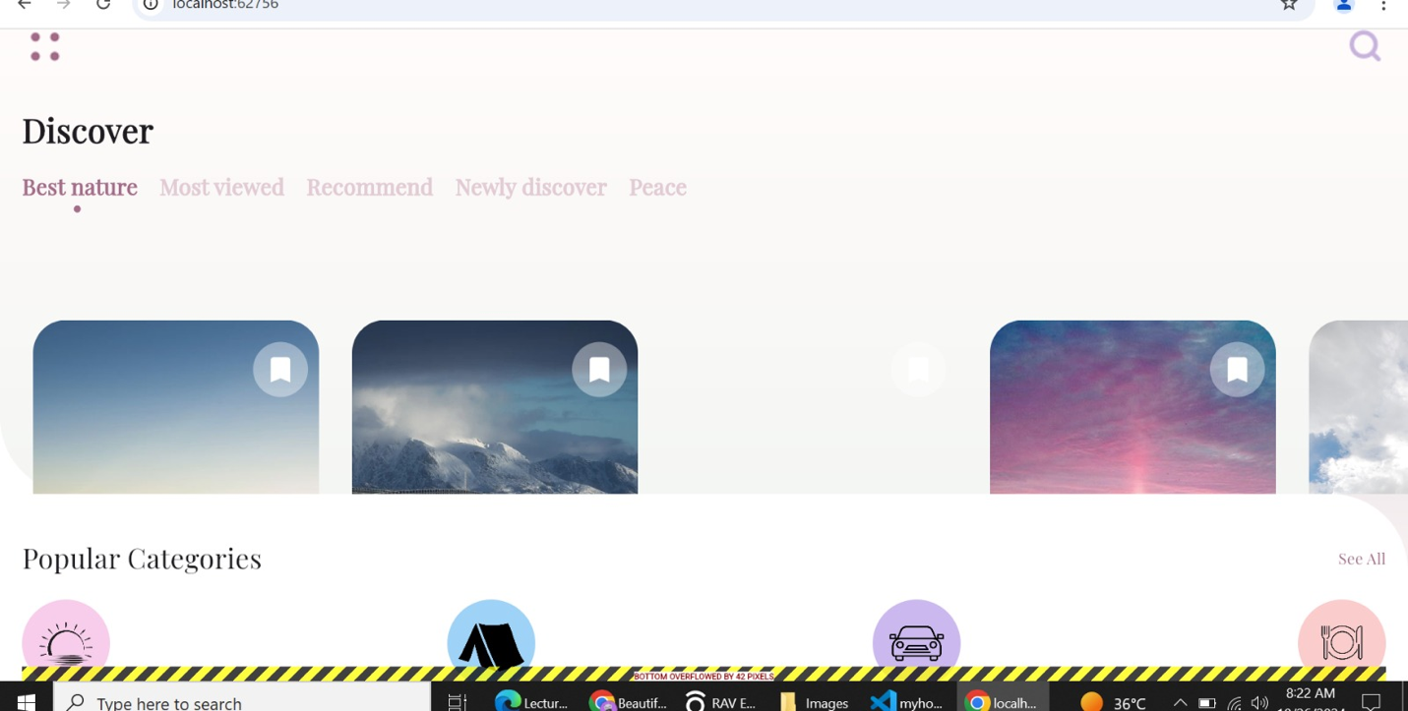

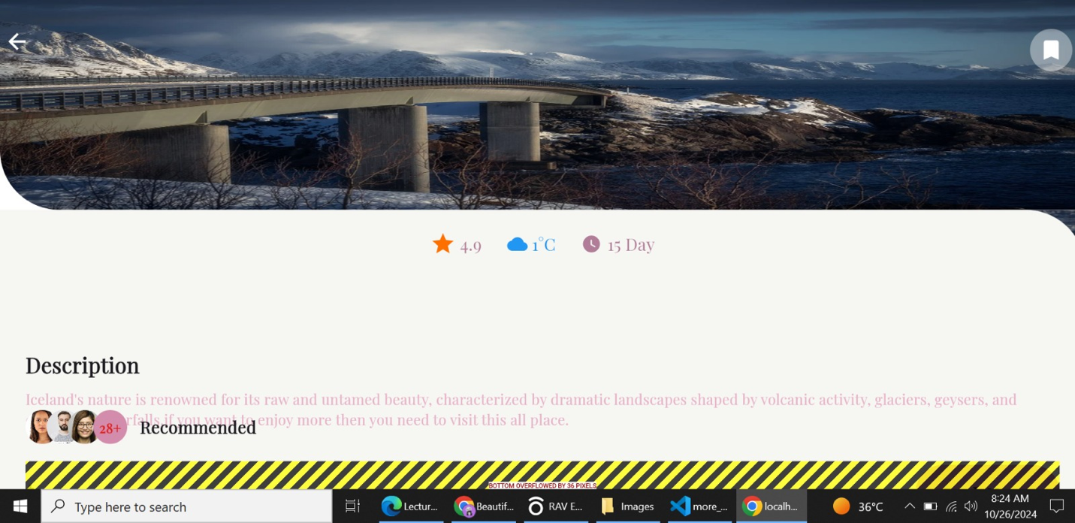

**Data Storage (With justification for using a particular database):**

**Data Storage: A Comprehensive Analysis:**

When selecting a database for a travel app, several factors should be considered:

1. Data Structure:

The app will likely store structured data like user profiles, location details, reviews, and bookings. Relational databases are well-suited for structured data, as they organize information into tables with rows and columns.

1. Scalability:

As the app grows in popularity, it will need to handle increasing amounts of data and users. A scalable database is essential to accommodate future growth without compromising performance.

1. Performance:

The app should provide a fast and responsive user experience.

The database should be able to handle queries and updates efficiently.

**APIs/Packages/Plug-ins (if used with justifications for using them):**

A robust travel app often leverages various APIs, packages, and plugins to enhance its functionality and user experience. Here are some key examples:

1. Mapping APIs:

**Google Maps Platform:**

Provides mapping, directions, and geocoding services.

Offers features like place search, route optimization, and heatmaps.

Benefits:

Highly customizable, offline capabilities, and integration with other Mapbox services.

2. Weather APIs:

**OpenWeatherMap:**

Provides current weather data, forecasts, and historical weather information.

Offers API endpoints for various weather parameters like temperature, humidity, and wind speed.

Benefits:

Free tier, easy to use, and reliable data.

5. Authentication and Authorization:

**Firebase Authentication:**

Offers various authentication methods (email/password, Google, Facebook, etc.).

Provides features like user management, password reset, and email verification.

Benefits:

Easy to use, scalable, and secure.

**Issues and Bugs Encountered and Resolved during Development:**

During the development of a travel app, developers often encounter a range of challenges. Here are some common issues and their potential resolutions:

1. API Integration and Data Consistency:

**Issue:**

API rate limits, data inconsistencies, or API downtime can disrupt app functionality.

**Resolution:**

Implement robust error handling and retry mechanisms.

Cache API responses to reduce load and improve performance.

Use asynchronous programming to handle API calls efficiently.

Monitor API usage and adjust usage patterns to avoid exceeding rate limits.

2. User Interface (UI) and User Experience (UX) Challenges:

**Issue:**

Poor UI/UX design can lead to user frustration and low app ratings.

**Resolution:**

Conduct thorough user testing and gather feedback.

Prioritize intuitive navigation and clear information hierarchy.

Use responsive design principles to ensure a consistent experience across devices.

Optimize loading times and app performance.

3. Device Compatibility and Fragmentation:

**Issue:**

Different device screen sizes, operating systems, and browser versions can cause compatibility issues.

**Resolution:**

Thoroughly test the app on a variety of devices and emulators.

Use responsive design principles to adapt the UI to different screen sizes.

Consider using cross-platform frameworks like Flutter or React Native to streamline development.

4. Geolocation and Mapping Issues:

**Issue:**

Inaccurate location data, slow map loading, or mapping API limitations can impact the user experience.

**Resolution:**

Use reliable geolocation APIs and consider hybrid approaches (GPS, Wi-Fi, and cell tower triangulation).

Optimize map loading and rendering.

Implement error handling for cases where geolocation services are unavailable.